AI ASSISTED CODING
ASSIGNMENT – 11.5
Name : A.RUCHITHA
Ht No : 230352365
Batch : 33
Task Description #1 – Stack Implementation
Task: Use AI to generate a Stack class with push, pop, peek, and is_empty
methods.
Sample Input Code:
class Stack: pass
Expected Output:
• A functional stack implementation with all required methods and
Docstring.
Prompt :
Generate a Python class Stack using a list.
Include push, pop, peek, and is_empty methods.
Add docstrings, comments, and example usage.
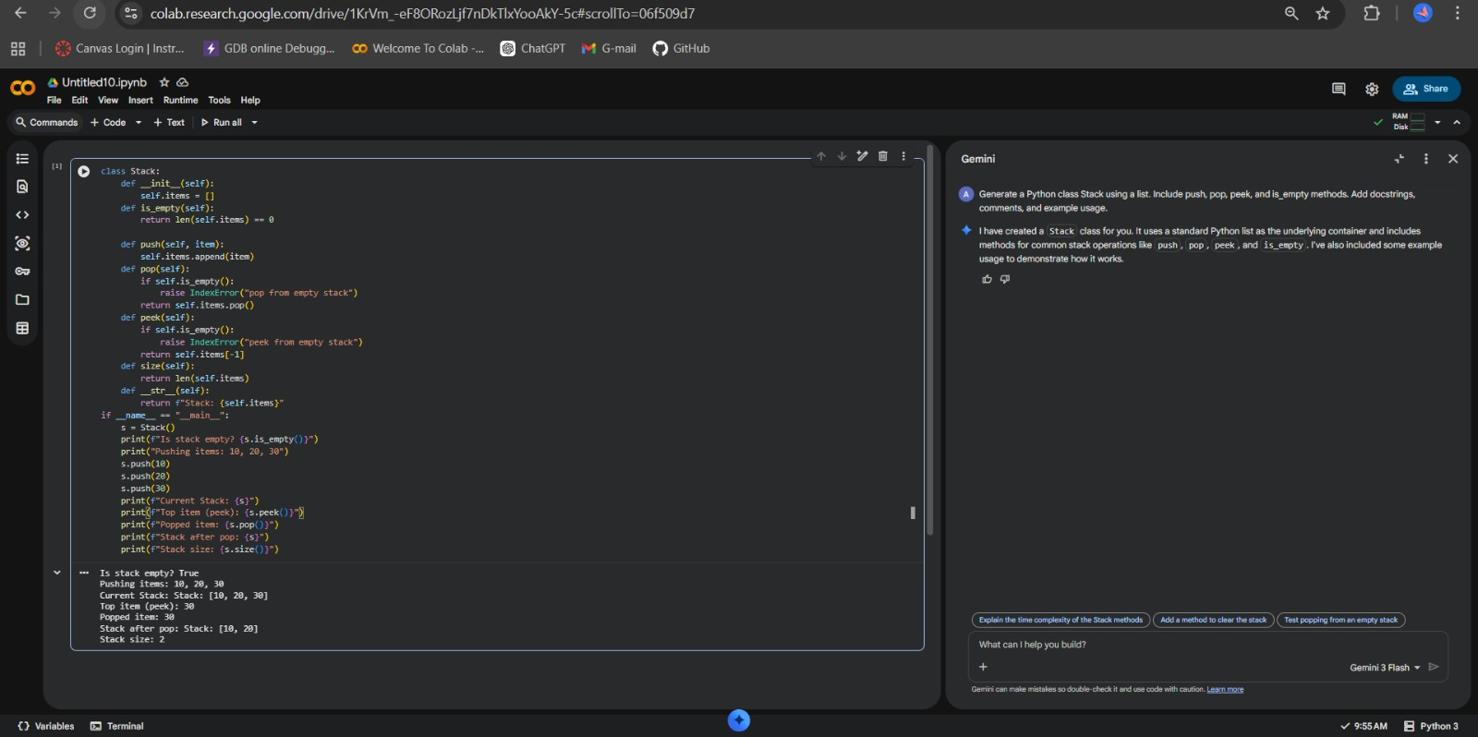
Task Description #2 – Queue Implementation
Task: Use AI to implement a Queue using Python lists.
Sample Input Code:
class Queue:
pass
Expected Output:
• FIFO-based queue class with enqueue, dequeue, peek, and size
methods.
Prompt used :
Generate a Python class Queue using a list.
Include enqueue, dequeue, peek, and size methods.
Follow FIFO principle with comments and example usage.
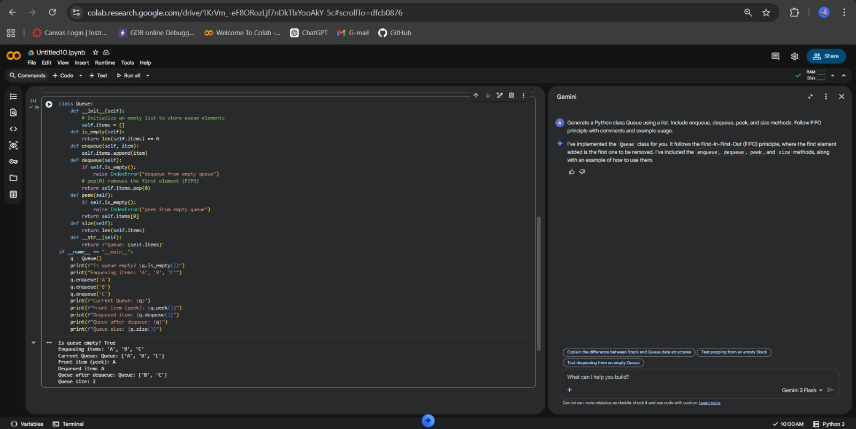
Task Description #3 – Linked List
Task: Use AI to generate a Singly Linked List with insert and display
methods.
Sample Input Code:
class Node:
pass
class LinkedList:
pass
Expected Output:
• A working linked list implementation with clear method
documentation.
Prompt used :
Generate Node and LinkedList classes in Python.
Include insert (at end) and display methods.
Add clear docstrings and example usage.
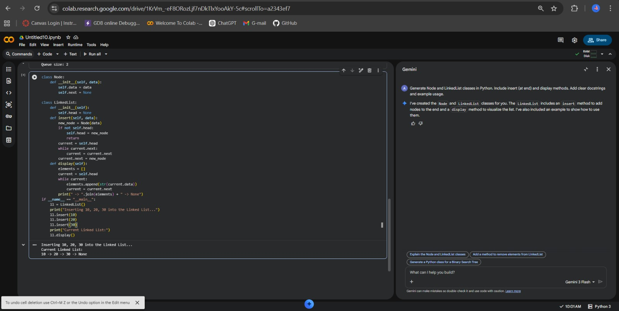
Task Description #4 – Hash Table
Task: Use AI to implement a hash table with basic insert, search, and
delete methods.
Sample Input Code:
class Hash Table:
pass
Expected Output:
• Collision handling using chaining, with well-commented methods.
Prompt used :
Generate a Python HashTable class using chaining.
Include insert, search, and delete methods.
Add comments, hash function, and example usage.
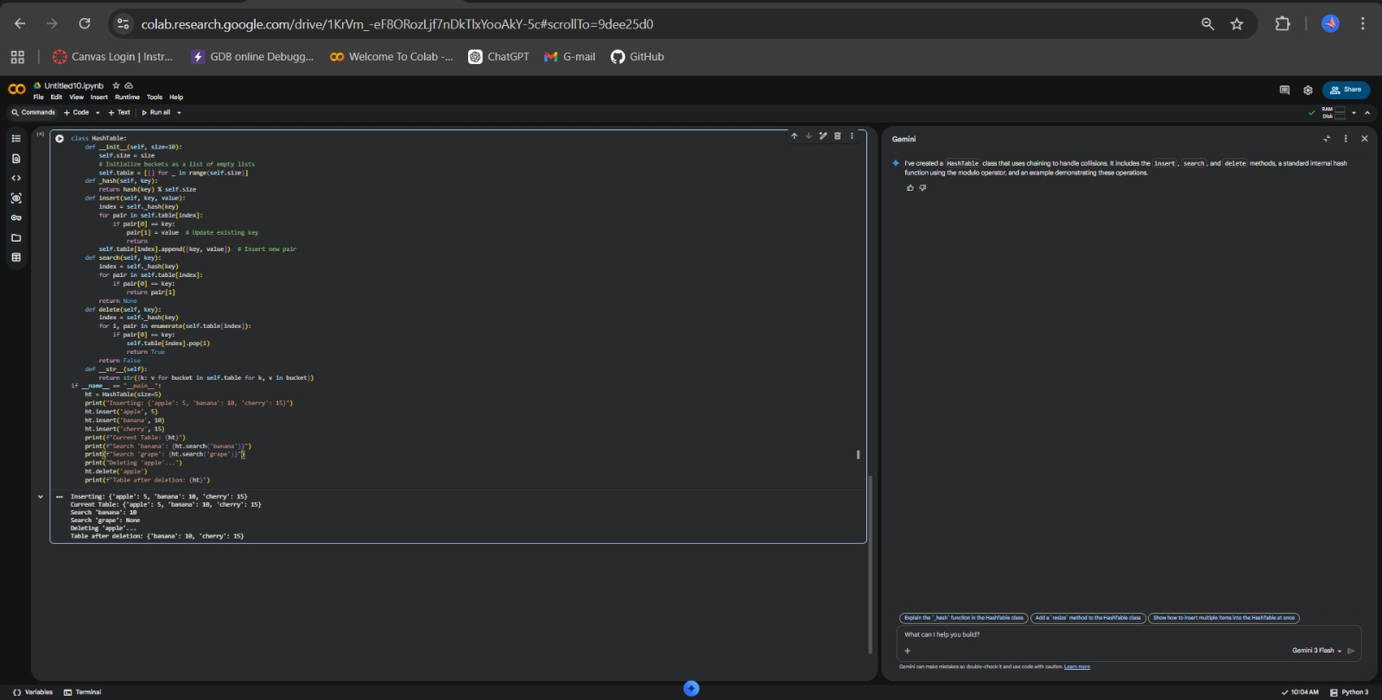
Task Description #5 – Graph Representation
Task: Use AI to implement a graph using an adjacency list.
Sample Input Code:
class Graph : pass
Expected Output:
• Graph with methods to add vertices, add edges, and displayconnections.
Prompt Used :
Generate a Python Graph class using adjacency list.
Include add_vertex, add_edge, and display methods.
Add comments and example usage.
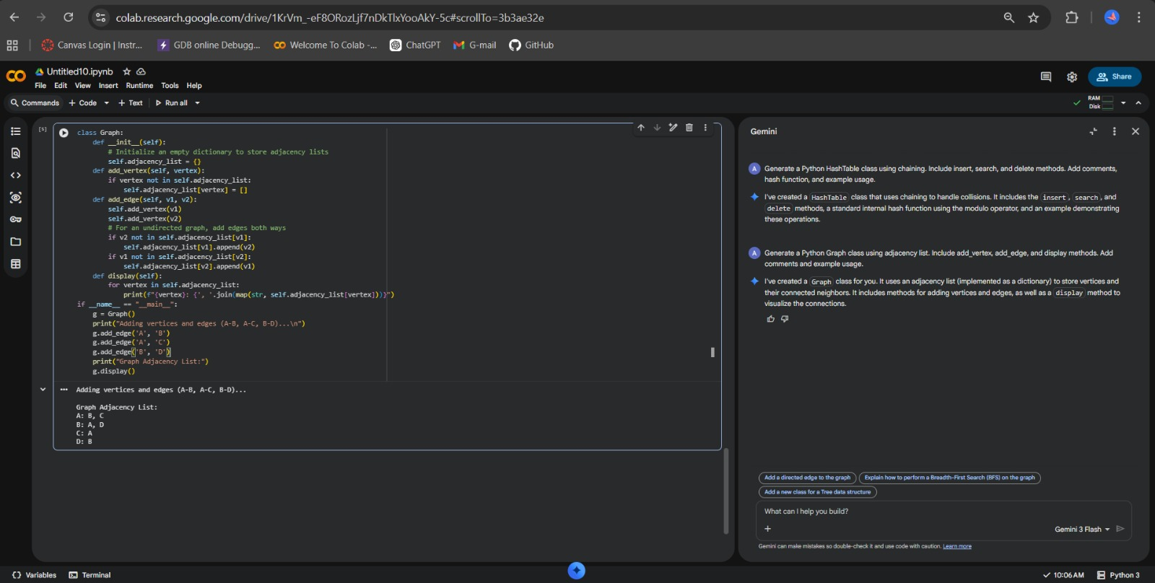
Task Description #6: Smart Hospital Management System – Data
Structure Selection
A hospital wants to develop a Smart Hospital Management System that
handles:
1. Patient Check-In System – Patients are registered and treated in
order of arrival.
2. Emergency Case Handling – Critical patients must be treated first.
3. Medical Records Storage – Fast retrieval of patient details using
ID.
4. Doctor Appointment Scheduling – Appointments sorted by time.
5. Hospital Room Navigation – Represent connections between
wards and rooms.
Student Task
• For each feature, select the most appropriate data structure from
the list below:
o Stack
o Queue
o Priority Queue
o Linked List
o Binary Search Tree (BST)
o Graph
o Hash Table
o Deque
• Justify your choice in 2–3 sentences per feature.
• Implement one selected feature as a working Python program with
AI-assisted code generation.
Expected Output:
• A table mapping feature → chosen data structure → justification.
• A functional Python program implementing the chosen feature
with comments and docstrings.
Prompt Used : ( FOR TABLE )
Generate a formatted table for a Smart Hospital Management System.
Features:
1. Patient Check-In System
2. Emergency Case Handling
3. Medical Records Storage
4. Doctor Appointment Scheduling
5. Hospital Room Navigation
Choose the most appropriate data structure from:
Stack, Queue, Priority Queue, Linked List, Binary Search Tree (BST),
Graph, Hash Table, Deque.
Requirements:
- Create a table: Feature | Data Structure | Justification
- Provide 2–3 sentence justification for each feature.
- Keep explanations clear and concise.
Prompt Used : ( FOR CODE )
Generate a working Python program implementing Emergency Case Handling
using a Priority Queue.
Requirements:
- Use heapq module.
- Each patient has name and severity (lower number = higher priority).
- Methods:
add_patient(name, severity)
treat_patient()
display_patients()
- Add docstrings and comments.
- Include example usage.
- Mention time complexity in comments.
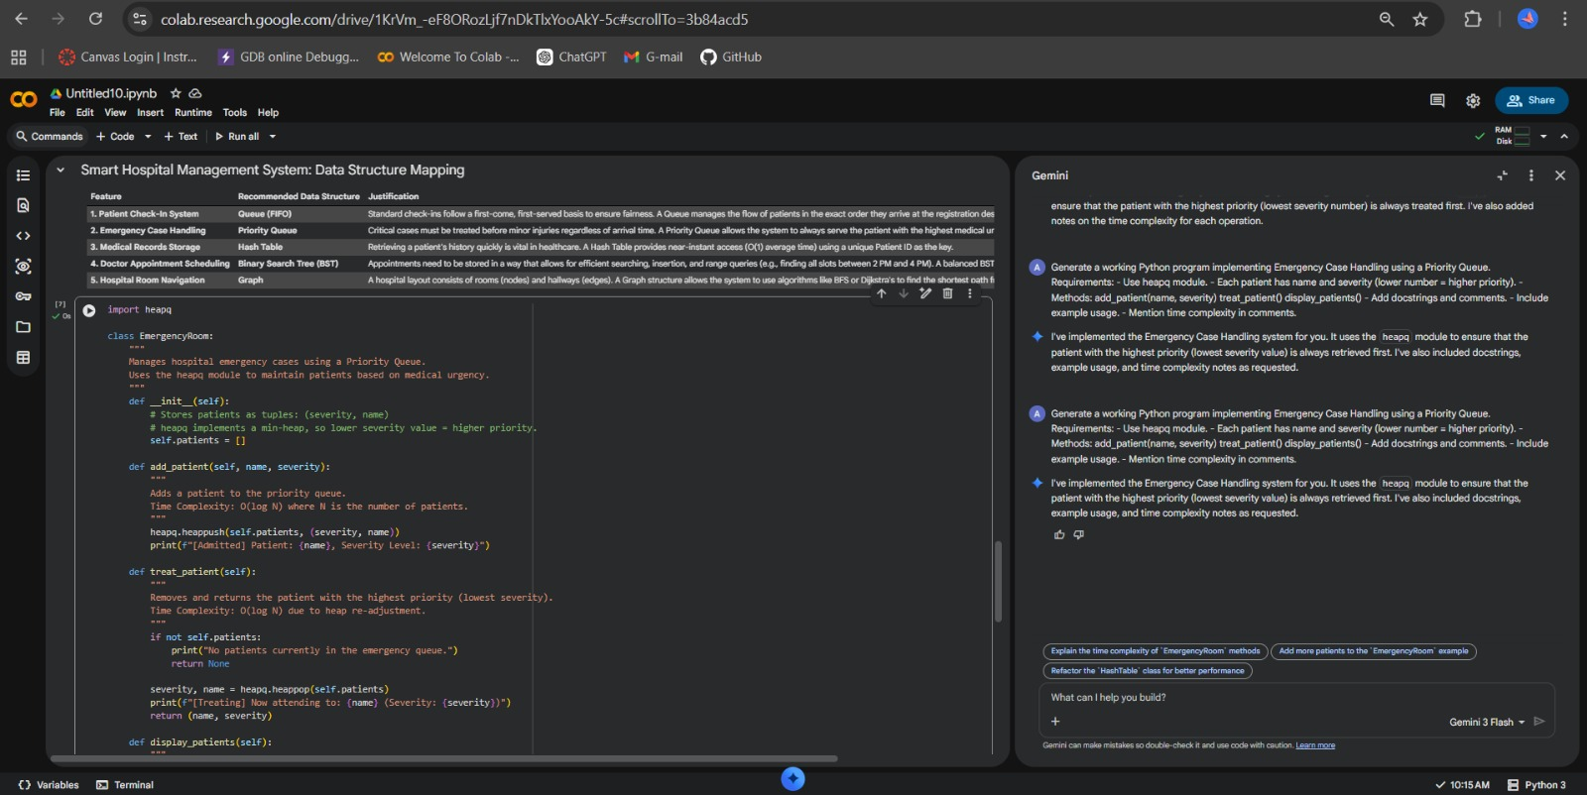
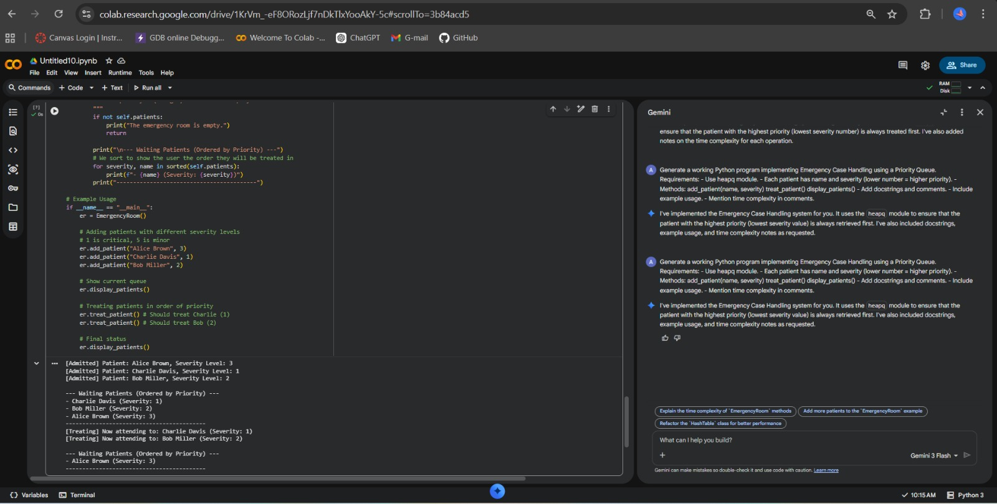
Task Description #7: Smart City Traffic Control System
A city plans a Smart Traffic Management System that includes:
1. Traffic Signal Queue – Vehicles waiting at signals.
2. Emergency Vehicle Priority Handling – Ambulances and fire trucks
prioritized.
3. Vehicle Registration Lookup – Instant access to vehicle details.
4. Road Network Mapping – Roads and intersections connected
logically.
5. Parking Slot Availability – Track available and occupied slots.
Student Task
• For each feature, select the most appropriate data structure from
the list below:
o Stack
o Queue
o Priority Queue
o Linked List
o Binary Search Tree (BST)
o Graph
o Hash Table
o Deque
• Justify your choice in 2–3 sentences per feature.
• Implement one selected feature as a working Python program with
AI-assisted code generation.
Expected Output:
• A table mapping feature → chosen data structure → justification.
• A functional Python program implementing the chosen feature
with comments and docstrings.
Prompt Used : (FOR TABLE)
Generate a formatted table for a Smart Traffic Management System.
Features:
1. Traffic Signal Queue
2. Emergency Vehicle Priority Handling
3. Vehicle Registration Lookup
4. Road Network Mapping
5. Parking Slot Availability
Choose the most appropriate data structure from:
Stack, Queue, Priority Queue, Linked List, Binary Search Tree (BST),
Graph, Hash Table, Deque.
Requirements:
- Format as a table: Feature | Data Structure | Justification
- Provide 2–3 sentence justification per feature.
- Keep explanations simple and clear.
PROMPT USED : (FOR CODE)
Generate a working Python program implementing Vehicle Registration Lookup
using a Hash Table.
Requirements:
- Store vehicle_number as key.
- Store owner_name and vehicle_type as values.
- Methods:
register_vehicle()
search_vehicle()
delete_vehicle()
- Add proper docstrings and comments.
- Include example usage.
- Mention time complexity in comments.
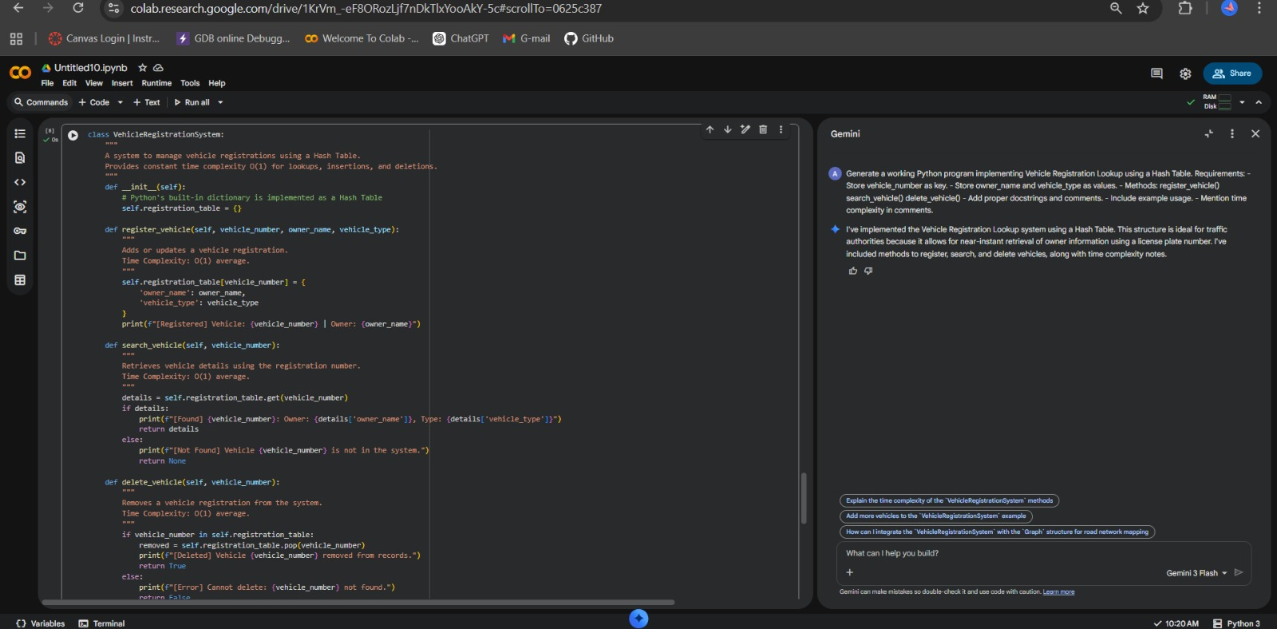
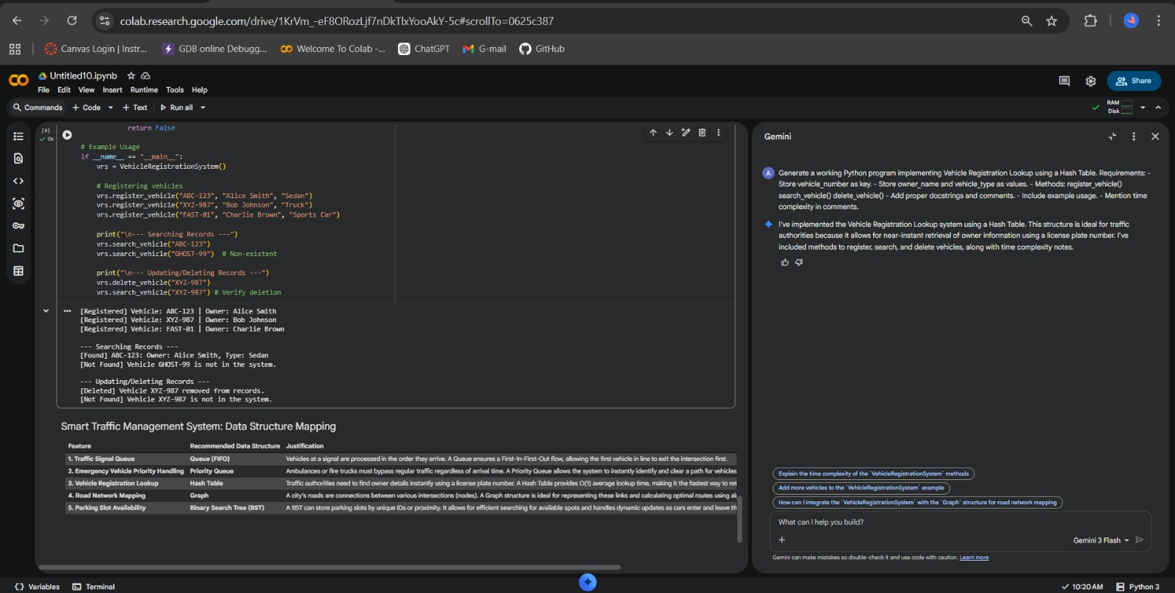
Task Description #8: Smart E-Commerce Platform – Data Structure
Challenge
An e-commerce company wants to build a Smart Online Shopping System
with:
1. Shopping Cart Management – Add and remove products
dynamically.
2. Order Processing System – Orders processed in the order they are
placed.
3. Top-Selling Products Tracker – Products ranked by sales count.
4. Product Search Engine – Fast lookup of products using product ID.
5. Delivery Route Planning – Connect warehouses and delivery
locations.
Student Task
• For each feature, select the most appropriate data structure from
the list below:
o Stack
o Queue
o Priority Queue
o Linked List
o Binary Search Tree (BST)
o Graph
o Hash Table
o Deque
• Justify your choice in 2–3 sentences per feature.
• Implement one selected feature as a working Python program with
AI-assisted code generation.
Expected Output:
• A table mapping feature → chosen data structure → justification.
• A functional Python program implementing the chosen feature
with comments and docstrings.
PROMPT USED : ( FOR TABLE )
Generate a formatted table for a Smart E-Commerce Platform.
Features:
1. Shopping Cart Management
2. Order Processing System
3. Top-Selling Products Tracker
4. Product Search Engine
5. Delivery Route Planning
Choose the most appropriate data structure from:
Stack, Queue, Priority Queue, Linked List, Binary Search Tree (BST),
Graph, Hash Table, Deque.
Requirements:
- Format as: Feature | Data Structure | Justification
- Provide 2–3 sentence justification per feature.
- Keep explanations short and clear.
PROMPT USED : (FOR CODE)

